Traffic Squad Management System



Capital University of Science and Technology

Department of Computer Science

Group Members:

Mobeen Saeed Bcs2130572

Ruquiya Nasir Bcs213065

Laiba Shahzadi Bcs213053

Submitted to:

Sir Salman Ahmed

A project report presented to

Capital University of Science and Technology

January 14, 2023

TRAFFIC SQUAD DATABASE MANAGEMENT SYSTEM

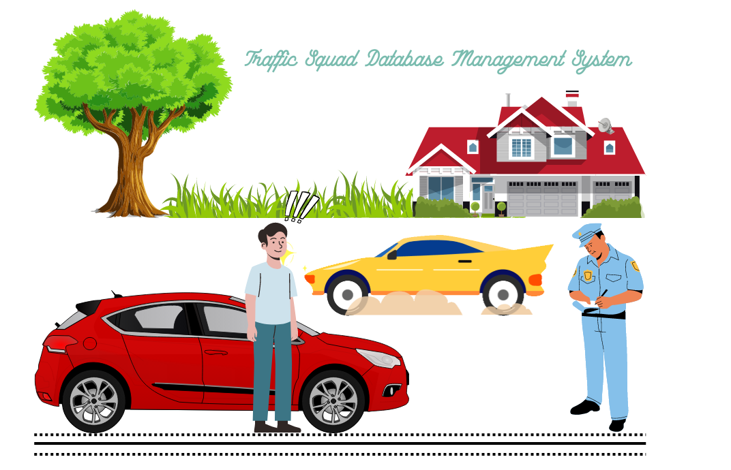

**ABSTRACT**

“Traffic Squad Management System “would help the traffic police as well as the police by means of time and efficiency. The increasing importance of corruption has become a major factor. The existing system makes the use of pen and paper .As the system consists of paperwork the papers mostly get damaged or tempered.

This system would allow traffic police to create online challan with the vehicle owner, and vehicle photo as proof, user would receive the challan receipt with fine details.

PROJECT MODULES:

It would have three modules:

o Admin

o Traffic police

o User

In Traffic Squad Management System Project we use PHP and MySQL Database.

Table of Contents

CASE STUDY 5

ERD Entity Relationship Diagram 6

RDM (Relational Database Model) 7

Queries………………………………………………………………………………………………………………………………………….8

Implementation…………….…………………………………………………………………………………………………………….9

**Table of Figures**

Figure 1 ERD 6

Figure 2 Implementation 8

Figure 3 create table query 9

# CASE STUDY

“*Traffic Squad Management System* “would help the traffic police head office as well as the police officer through time and efficiency. The increasing importance of corruption has become a major factor. Online challan system helps the driver to get their license easily on the spot.

The system maintains a record of police officers working in the police station that has a unique *name, location, and code*.

After a traffic police staff is registered all the traffic police officer that belongs to that specific station has all his/her records stored in them, which includes *name, id, Rank, contact number, address, qualification, e-mail, and CNIC*.

An officer can file a challan that has a unique number, place of violation, and offense date stored for all those people breaking traffic rules. Only one officer can challan zero or many offenders. Moreover, an officer can search that challan details through challan number and, offender name and can view its details and status that whether it is paid or not, and the number of challans filed by him/her in particular periods.

If a citizen violates any traffic rules then an officer generates a challan for him/her that contains information about that offender, his/her vehicle, and the violation done by him/her.

The Violation list consists of all the details regarding the offense like *violation Id, Section act, violation name, and its penalty*. An offender can do and officer can charge many violations.

Offender details recorded are *Id, name, license number, license type, address, gender, contact number, CNIC, and E-mail*. And its vehicle details include a unique *number plate number, vehicle name and its type*. An offender can has one or many vehicle.

The offender would receive the challan receipt with fine details and have to log in to pay the challan fine which is imposed by traffic police. Furthermore, they can search challan by its number.



## ERD Entity Relationship Diagram

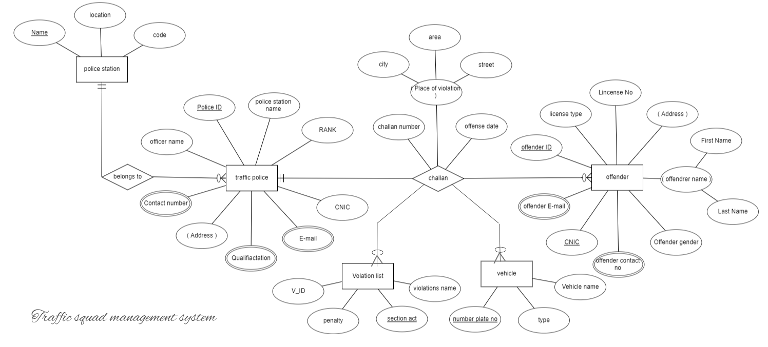

Figure 1 ERD



### RDM (Relational Database Model)

Policestation (Pname, code, location)

TrafficPolice (PoliceID, Pname, officername, RANK, CNIC, city, area, street)

Qualification (title, examname)

TrafficPoliceQualification (PoliceID, examname)

TContact_no (c_id, workphone, cellphone)

TrafficPoliceContact_no (PoliceID, c_id)

Te-mail (E-mID,e_address)

TrafficPoliceE-mail (E-mID, PoliceID)

Offender (PoliceID, offenderID, Licensetype, licenseNo, address, firstname, lastname, gender, CNIC,)

Ocontactno (c_id, workphone, cellphone)

Offendercontactno (offenderID, c_id)

Oe-mail (oE-mID,Oe_address)

OffenderE-mail (oE-mID, offenderID)

Challan (challanno, PoliceID, offenderID, Sectionact, Noplate, offensedate, city, street, area)

ViolationList (PoliceID, VID, violationname, penalty, Sectionact)

Vehicle (PoliceID, Noplate, vehcileName, type)



### Queries

create table policestation(Policestation_name varchar (225) NOT NULL,stationcode INT NOT NULL,location varchar(225) NOT NULL,PRIMARY KEY(Policestation_name));

create table trafficpolice(policeID varchar(225) NOT NULL,PoliceStationName varchar(225),FOREIGN KEY(PoliceStationName) REFERENCES policestation(Policestation_name),office_RANK varchar(225) NOT NULL,CNIC varchar(225) NOT NULL,city varchar(225) NOT NULL,area varchar(225) NOT NULL,street varchar(225) NOT NULL, PRIMARY KEY(policeID));

create table qualification(EXAM_Name varchar(225) NOT NULL, title varchar(225) NOT NULL,PRIMARY KEY(EXAM_Name));

create table tpqualification(Police_ID varchar(225),FOREIGN KEY(Police_ID) REFERENCES trafficpolice(policeID),Exam_given varchar(225),FOREIGN KEY(Exam_given) REFERENCES qualification(EXAM_Name));

create table tcontact_no(C_id INT NOT NULL AUTO_INCREMENT ,workphone varchar(225) NOT NULL, cellphone varchar(225) NOT NULL,PRIMARY KEY(C_id));

create table tpolicecontact(PoliceID varchar(225),FOREIGN KEY(PoliceID) REFERENCES trafficpolice(policeID),C_ID INT,FOREIGN KEY(C_ID) REFERENCES tcontact_no(C_id));

create table email(E_mID INT NOT NULL AUTO_INCREMENT,e_address varchar(225),PRIMARY KEY(E_mID));

create table tpe_mail(police_ID varchar(225),FOREIGN KEY(police_ID) REFERENCES trafficpolice(policeID),e_mID INT,FOREIGN KEY(e_mID) REFERENCES email(E_mID));

CREATE TABLE Offender(Offender_ID INT NOT NULL AUTO_INCREMENT,Police_ID INT,FOREIGN KEY(Police_ID) REFERENCES trafficepolice(policeID),First_Name varchar(225) NOT NULL, Last_Name varchar(225) NOT NULL,Gender varchar(225) NOT NULL, CNIC varchar(225) NOT NULL,licensetype varchar(225) NOT NULL, license_No varchar(225) NOT NULL,city varchar(225) NOT NULL,area varchar(225) NOT NULL,street varchar(225) NOT NULL,PRIMARY KEY(Offender_ID));

create table ocontact_no(oc_id INT NOT NULL AUTO_INCREMENT,oworkphone varchar(225) NOT NULL, ocellphone varchar(225) NOT NULL,PRIMARY KEY(oc_id));

create table offendercontact(OffenderID INT,FOREIGN KEY(OffenderID) REFERENCES Offender(Offender_ID),OC_ID INT, FOREIGN KEY(OC_ID) REFERENCES ocontact_no(oc_id));

create table oe_mail(oE_mID INT NOT NULL AUTO_INCREMENT,oE_address varchar(225) NOT NULL,PRIMARY KEY(oE_mID));

create table offendere_mail(OFFENDER_ID INT,FOREIGN KEY(OFFENDER_ID) REFERENCES Offender(Offender_ID),oe_mID INT, FOREIGN KEY(oe_mID) REFERENCES oe_mail(oE_mID) );

create table violationlist(section_act varchar(225) NOT NULL,Violation_name varchar(225) NOT NULL, penalty INT NOT NULL, VID INT NOT NULL AUTO_INCREMENT,police_ID varchar(225),FOREIGN KEY(police_ID) REFERENCES trafficpolice(policeID),PRIMARY KEY(section_act));

create table vehicle(police_ID varchar(225),FOREIGN KEY(police_ID) REFERENCES trafficpolice(policeID),No_plate varchar(225) NOT NULL,Vehicle_name varchar(225) NOT NULL, PRIMARY KEY(No_plate));

create table challan(Challan_no varchar(225) NOT NULL,OFFENDER_ID INT,FOREIGN KEY(OFFENDER_ID) REFERENCES Offender(Offender_ID),POLICE_ID varchar(225),FOREIGN KEY(POLICE_ID) REFERENCES trafficpolice(policeID),SECTION_ACT varchar(225),FOREIGN KEY(SECTION_ACT) REFERENCES violationlist(section_act),NO_PLATE varchar(225),FOREIGN KEY(NO_PLATE) REFERENCES vehicle(No_plate),offense_date DATE,city varchar(225) NOT NULL,area varchar(225) NOT NULL,street varchar(225) NOT NULL,PRIMARY KEY(Challan_no));



#### Implementation

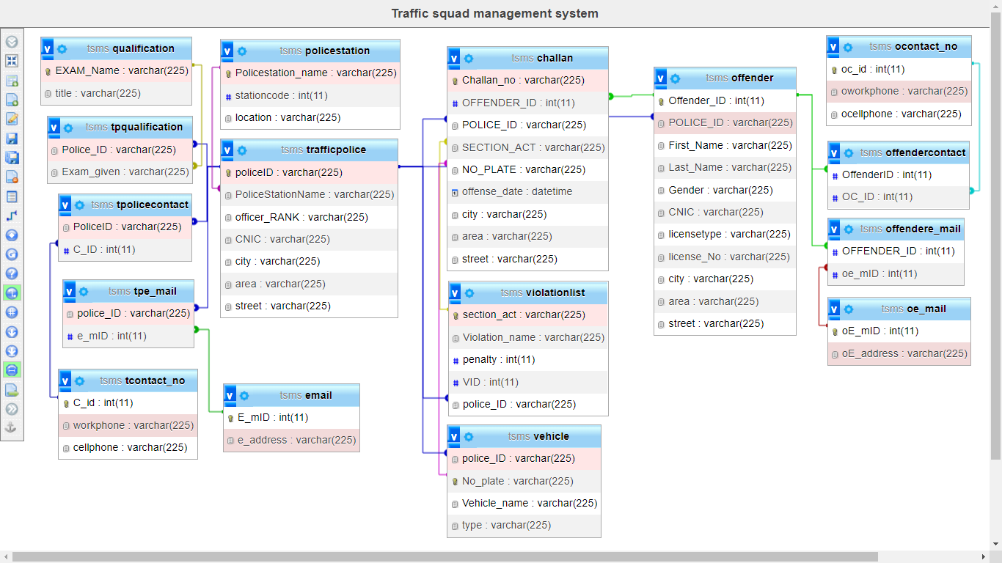



Figure 2 Implementation

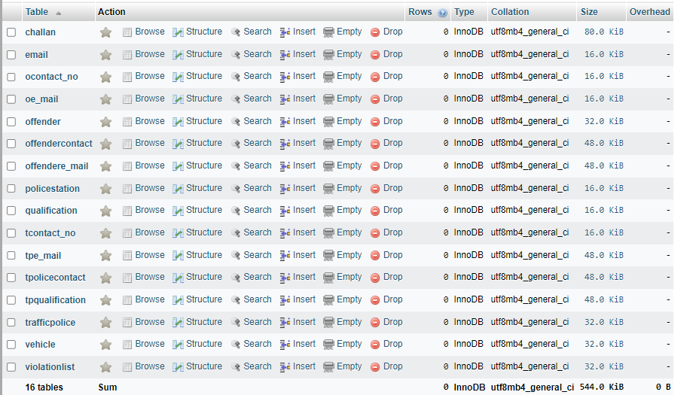

Figure 3 create table query

